

Requirement & Design Specification
Global Access Management System (GAMS)
Version: 1.0

– DaNang, May 2026 –

Record of Changes
Version | Date | A*  M, D | In charge | Change Description
V1.0 | 21/5 | A | All Members | Add Actor, Complete Use Case Diagram
V1.0 | 22/5 | A | All Members | Complete Feature descriptions
V1.0 | 27/5 | A | All Members | Complete Overall Functionalities
V1.0 | 29/5 | A | All Members | Complete Database Design
V1.0 | 1/6 | A | All Members | Complete Requirement Specifications
V1.0 | 5/6 | A | All Members | Complete Code Packages
V1.0 | 7/6 | A | All Members | Complete Design Specifications
*A - Added M - Modified D - Deleted

Contents
Record of Changes 2
I. Overview 4
1. User Requirements 4
1.1 Actors 4
1.2 Use Cases 4
2. Overall Functionalities 5
2.1 Screens Flow 5
2.2 Screen Descriptions 5
2.3 Screen Authorization 5
2.4 Non-UI Functions 6
3. System High Level Design 6
3.1 Database Design 6
3.2 Code Packages 7
II. Requirement Specifications 8
1. <<Feature Name>> 8
1.1 <<UseCaseCode_UC Name>> 8
2. Common Functions 11
2.1 UC-2_Login System 11
3. Patron Feature 12
3.1 UC-5_Order a Meal 12
3.2 UC-6_Register for Payroll Deduction 13
III. Design Specifications 14
1. <<Feature Name>> 14
1.1 <<SubFeature Name>> 14
1.2 System Access 15
IV. Appendix 19
1. Assumptions & Dependencies 19
2. Limitations & Exclusions 19
3. Business Rules 19
4. .. 19

I. Overview

1. User Requirements

1.1 Actors
# | Actor | Description
1 | Admin | Manages the entire system including users, vehicles, reports, and platform settings. Admin is a specialized role of Customer.
2 | Guest | Unregistered user who can browse the website, search motorbikes, and view vehicle information without logging in.
3 | Customer | Registered user who can book motorbikes, make payments, manage bookings, and submit reviews.
4 | Owner | Manages rental shop information, motorbike inventory, pricing, and rental operations. Owner is a specialized role of Customer.
5 | Staff | Supports daily rental activities such as confirming bookings, checking vehicle conditions, and handling returns. Staff is a specialized role of Customer.

1.2 Use Cases

a. Diagram(s)
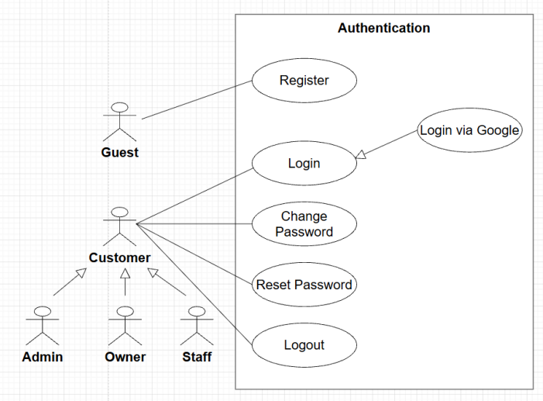
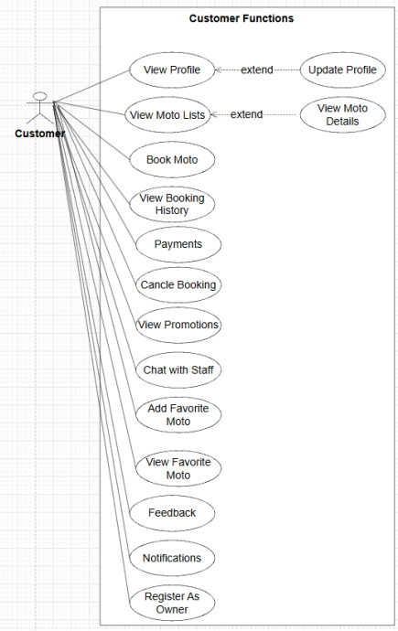
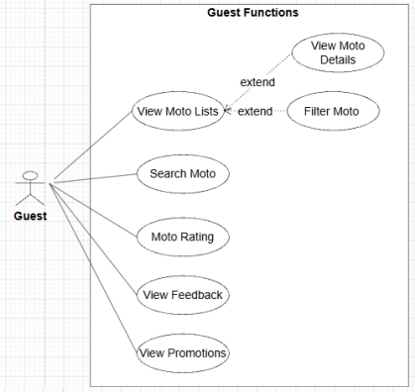
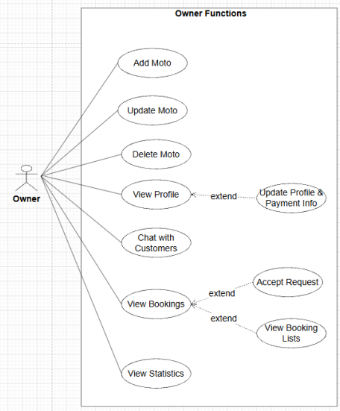
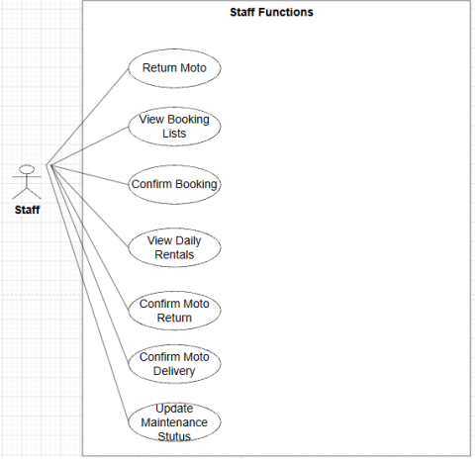
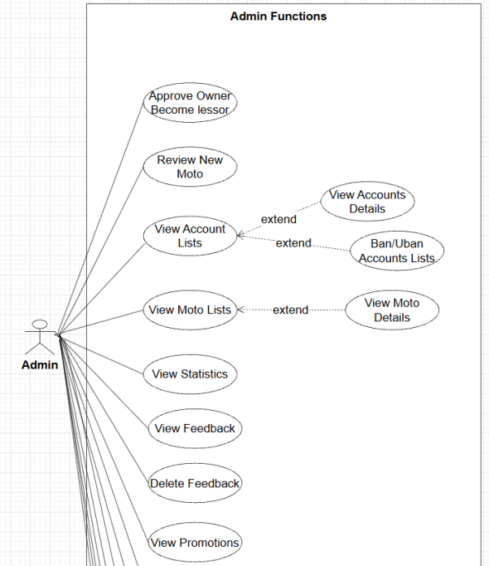
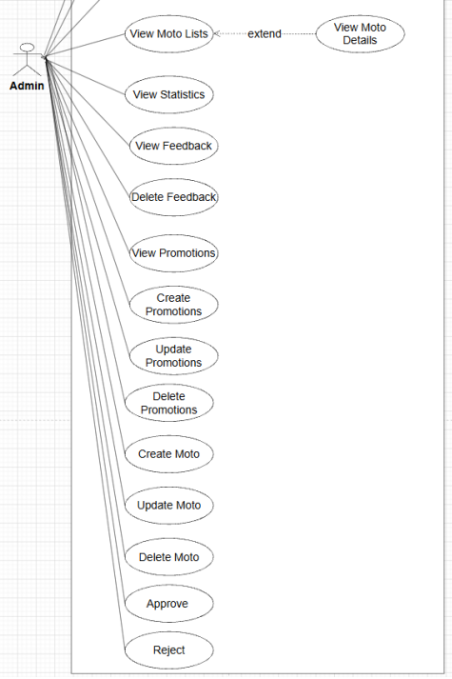

b. Descriptions
ID | Feature | Use Case | Use Case Description
01 | Authentication | Register | Allows a Guest to register a new account on the system.
02 | Authentication | Login | Permits authenticated users (Customer, Admin, Staff) to log in to access protected areas.
03 | Authentication | Login via Google | Allows Customers to authenticate quickly using Google Single Sign-On (SSO).
04 | Authentication | Logout | Terminates the current active user session securely.
05 | Authentication | Reset AuthenticationPassword | Enables users to request a password recovery option if they forget their password.
06 | Authentication | Change Password | Allows logged-in users to update their current password to keep accounts secure.
07 | Authentication | Profile View | Allows users to view their registered personal profile information.
08 | Authentication | Update Profile | Allows users to modify and update their personal profile details.
09 | Motorbike Catalog | Motorbike List | Allows Guests and Customers to browse the comprehensive collection of motorbikes.
10 | Motorbike Catalog | Motorbike Detail | Displays explicit technical specifications, pricing, and specific details of a chosen motorbike.
11 | Motorbike Catalog | Search Motorbike | Provides text search tools to let users find motorbikes by typing keywords.
12 | Motorbike Catalog | Filter Motorbike | Enables filtering options to narrow down vehicles based on criteria (e.g., brand, type, engine capacity).
13 | Motorbike Catalog | Sort Motorbike | Allows sorting of the motorbike list by price, popularity, or rating.
14 | Motorbike Catalog | Related Motorbikes | Displays recommendations of alternative, similar motorbikes when viewing a vehicle.
15 | Motorbike Catalog | Motorbike Rating | Displays aggregate performance scores and ratings from previous customers.
16 | Motorbike Catalog | Motorbike Review | Allows Customers to write text reviews and post feedback on vehicles they have used.
17 | Motorbike Catalog | Favorite Motorbikes | Enables Customers to bookmark and save specific motorbikes into a personal wishlist.
18 | Booking | Create Booking | Enables a Customer to select dates, choose an available vehicle, and submit a rental request.
19 | Booking | Check Availability | Automatically verifies if a specific motorbike is free for the selected date range.
20 | Booking | Rental Conflict Validation | System background logic that enforces schedules and prevents overlapping bookings for the same vehicle.
21 | Booking | Rental Price Calculation | System background logic that aggregates daily vehicle rates to compute the exact rental contract total fee.
22 | Booking | Booking List | Allows a Customer to view a summary list of all their historical and active rental bookings.
23 | Booking | Booking Detail | Displays the granular breakdown and configuration of an explicit booking order.
24 | Booking | Cancel Booking | Enables a Customer to request the termination of a future booking request.
25 | Booking | Booking Tracking | Allows real-time operational state tracking of a active booking lifecycle.
26 | Booking | Return Motorbike | Allows Staff to process incoming returned vehicles at the physical shop
27 | Booking | Late Return Fee | System background logic that computes overdue penalty prices if a bike is returned past the deadline.
28 | Payment | Cash Payment | Handles Cash on Delivery (COD) configuration where payment occurs at physical pickup.
29 | Payment | Online Payment | Routes the customer transaction request securely through an online electronic payment gateway.
30 | Payment | Payment History | Provides a readable transactional log of past financial payments made by the Customer.
31 | Verification | Upload Citizen ID | Allows Customers to upload images of their identity cards/CCCD for administrative compliance.
32 | Verification | Verify Customer Identity | Allows Admins to inspect uploaded credentials and transition customer authorization states.
33 | Notification | Booking Confirmation | Triggers an immediate notification/email confirmation text once a booking request is accepted.
34 | Notification | Booking Reminder | Automated system utility that triggers alerts to customers before their rental contract begins or ends.
35 | Notification | System Notification | Dispatches contextual, live in-app notifications directly to targeted users (Customer, Staff, Admin).
36 | Staff Management | View Booking List | Provides a unified management view of incoming rental booking requests for Staff review.
37 | Staff Management | Confirm Booking | Allows Staff to authorize and officially accept incoming pending customer bookings.
38 | Staff Management | Confirm Bike Pickup | Logs a verification stamp when a customer physically arrives and picks up the vehicle.
39 | Staff Management | Confirm COD Payment | Allows Staff to log and verify cash handovers collected during physical vehicle pick-ups.
40 | Staff Management | Update Motorbike Status | Allows Staff to change immediate vehicle statuses (e.g., Available, Rented, Maintenance).
41 | Staff Management | View Daily Rentals | Displays a dynamic scheduling calendar displaying daily operational pickups and handovers.
42 | Admin | Create Motorbike | Allows Admin to provision and add an entirely new vehicle asset record to the fleet inventory.
43 | Admin | Update Motorbike | Allows Admin to change information or metadata on existing vehicle profiles.
44 | Admin | Delete Motorbike | Allows Admin to archive or remove a vehicle record from active listings.
45 | Admin | Motorbike Category CRUD | Full Create, Read, Update, and Delete control over motorbike categorical classifications and tags.
46 | Admin | Inventory Update | Allows Admin to audit, adjust, and update global inventory records.
47 | Admin | Low Availability Alert | Automatic warning trigger flags on the Admin view when available fleets fall below a threshold.
48 | Admin | Booking Management | Grants comprehensive master control to audit, overwrite, or intervene in any booking on the system.
49 | Admin | User Management | Full administrative power to create, update, suspend, or manage roles of any account database row.
50 | Admin | Review Motorbikes | Allows Admin to approve newly listed vehicles before they go live on public menus.
51 | Admin | Delete Feedback | Moderation tool allowing Admin to purge malicious, inappropriate, or spam customer reviews.
52 | Admin | Promotion Management | System tool for managing marketing coupon codes, campaigns, and rental discounts.
53 | Admin | Dashboard | Central portal summary presenting visual metric charts and real-time operational summaries.
54 | Admin | Analytics | Generates advanced business intelligence reports covering system performance indicators.
55 | Admin | Top Rented Motorbikes | Displays system reporting on high-performing, frequently rented motorbike units.
56 | Support | Contact Staff | Provides communication support channels for Customers to request human staff assistance.
57 | Support | Report User | Allows Customers to flag fraudulent activities or report malicious platform profiles.

2. Overall Functionalities

2.1 Screens Flow
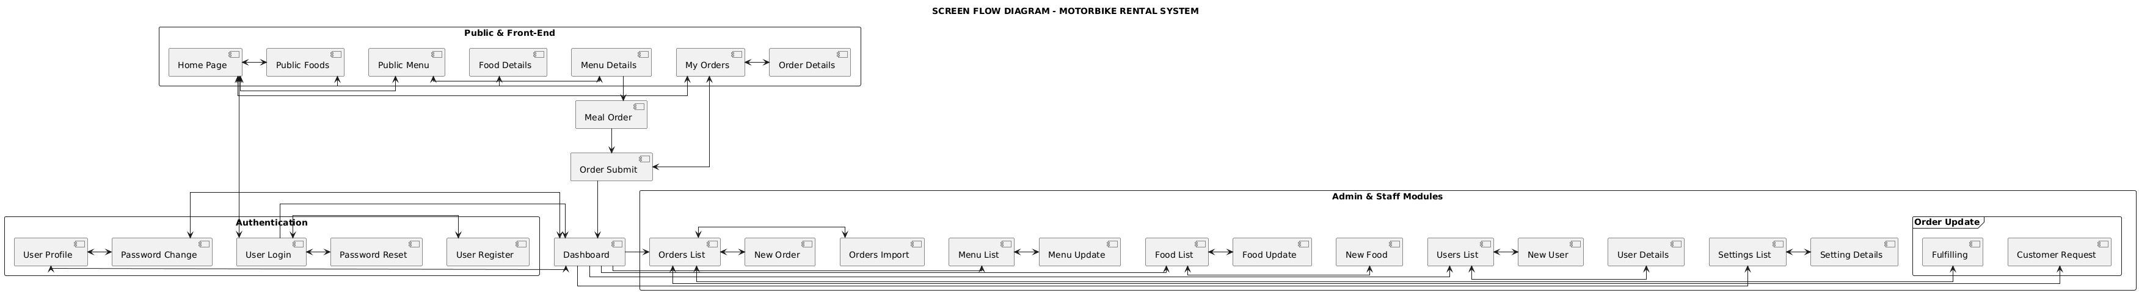

2.2 Screen Descriptions

# | Feature | Screen | Description
1 | Common / Auth | Login & Registration Screen | Form fields for email/password authentication, password recovery triggers, and single-click integration hooks for Google OAuth SSO.
2 | Motorbike Catalog | Motorbike Catalog Portal | A primary grid layout displaying available fleet vehicles. Integrates text search boxes, multi-attribute filter widgets (brand, category), and sorting dropdowns.
3 | Motorbike Catalog | Motorbike Details View | Displays granular specifications of a chosen vehicle, customer aggregate scores/reviews, dynamic related bike carousel recommendations, and action toggles to add to wishlists or initiate booking.
4 | Booking / Verification | Booking Checkout Desk | A multi-step form workflow where customers select dates, verify vehicle availability, upload a Citizen ID file attachment (.png/.jpg, max 5MB), and select the payment type.
5 | Booking | Customer Booking List | A personalized dashboard for customers to review their rental histories, track active booking lifecycle stages (Pending, Confirmed, Picked Up, Completed), or trigger cancellations.
6 | Staff Management | Daily Rental Board | A spreadsheet-style operational desk enabling Staff to monitor daily pickup/return schedules, input cash handovers, and change bike statuses.
7 | Admin Management | Admin Analytics Dashboard | An executive control panel rendering real-time KPI data charts, automated low availability alerts, and data tables for user accounts, promotions, and fleet inventory management.

2.3 Screen Authorization

Screen / Functional Action | Guest | Customer | Staff | Admin
Browse Catalog, Search & Filter Motorbikes | X | X | X | X
View Motorbike Ratings & Reviews | X | X | X | X
Submit Reviews & Manage Favorites Wishlist |  | X
Create Booking & Upload Citizen ID |  | X
Track Personal Booking List & Payment History |  | X
View Booking Requests & Daily Rental Calendars |  |  | X | X
Confirm Pickups, Returns, & COD Cash Payments |  |  | X | X
Update Immediate Motorbike Status Codes |  |  | X | X
Motorbike CRUD & Category Management |  |  |  | X
Approve New Bikes, Manage Users, & Verify IDs |  |  |  | X
Delete Inappropriate Feedback & Manage Promotions |  |  |  | X
Access Executive Dashboard & Analytics Reports |  |  |  | X

2.4 Non-UI Functions
# | Feature | System Function | Description
1 | Booking | Rental Conflict Validator | A real-time database indexing service running execution queries to intercept and block overlapping rental timelines for the same vehicle ID.
2 | Booking | Late Return Fee Processor | A scheduled background worker that evaluates overdue return hour gaps and automatically appends penalty charges according to system formulas.
3 | Booking | Automated Booking Reminder Driver | A background cron job that periodically polls reservation schedules and triggers email/SMS alerts to customers before their contract starts or ends.
4 | Notification | Live In-App Notification Pusher | A persistent WebSocket worker thread that instantly dispatches contextual alerts regarding booking confirmations and administrative alerts to active client screens.
5 | Admin | Low Availability Alert Sentinel | A continuous inventory counter service that flashes critical warning flags on the Admin dashboard when specific vehicle model volumes drop below safe thresholds.

3. System High Level Design

3.1 Database Design
[Provide the tables relationship like example below]

a. Database Schema
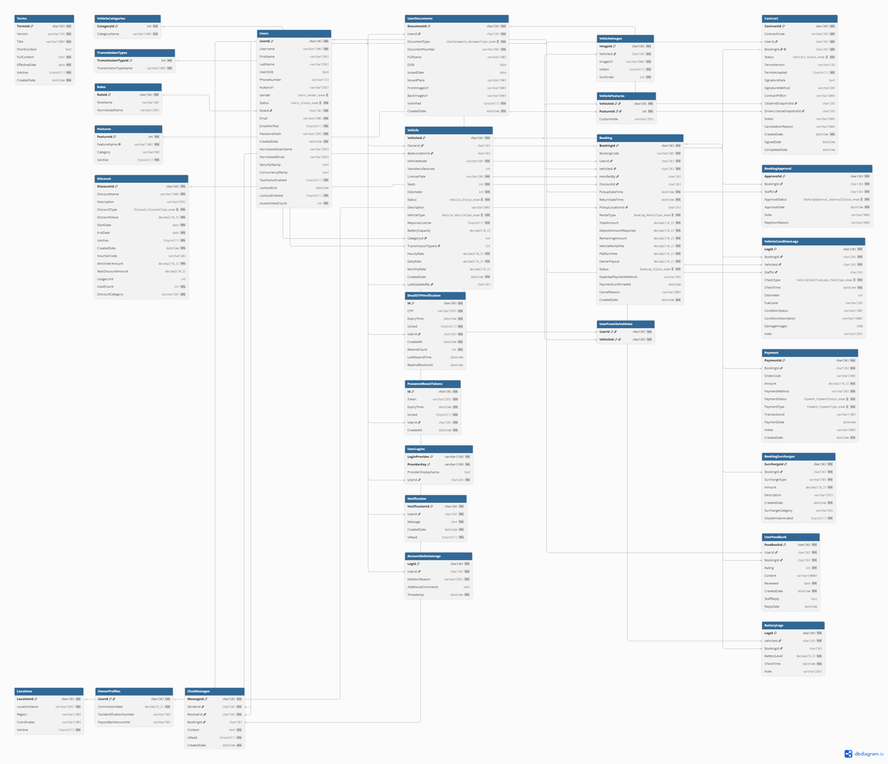

b. Table Descriptions
No | Table | Description
01 | Users | Stores identity, authentication, profile, and security status for all system users (including customers and vehicle owners).  - Primary keys: UserID  - Foreign keys: None
02 | UserDocuments | Manages legal verification documents uploaded by users, such as National IDs, passports, or driver's licenses.  - Primary keys: DocumentID  - Foreign keys: UserID (references Users)
03 | Vehicle | Contains detailed specifications, ownership, pricing, and current availability status of vehicles listed on the platform.  - Primary keys: VehicleID  - Foreign keys: OwnerID (references Users), CategoryID (references VehicleCategories), TransmissionTypeID (references TransmissionTypes)
04 | VehicleCategories | Classifies vehicles into distinct structural types (e.g., Sedan, SUV, Hatchback, Truck) for filtering and pricing strategies.  - Primary keys: CategoryID  - Foreign keys: None
05 | TransmissionTypes | Defines the operational transmission systems of the vehicles (e.g., Manual, Automatic).  - Primary keys: TransmissionTypeID  - Foreign keys: None
06 | VehicleImages | Stores media assets and image paths linked to listed vehicles for marketplace display.  - Primary keys: ImageID  - Foreign keys: VehicleID (references Vehicle)
07 | VehicleFeatures | Maps specific features and onboard amenities (e.g., GPS, Sunroof, Dashcam, Bluetooth) to vehicles.  - Primary keys: FeatureID, VehicleID  - Foreign keys: VehicleID (references Vehicle)
08 | Booking | Captures the core transactional lifecycle of a vehicle rental reservation, including rental durations, base costs, and order statuses.  - Primary keys: BookingID  - Foreign keys: CustomerID (references Users), VehicleID (references Vehicle), DiscountID (references Discount)
09 | BookingApproval | Records the audit log and approval state workflow executed by owners or system administrators for pending bookings.  - Primary keys: ApprovalID  - Foreign keys: BookingID (references Booking), ApproverID (references Users)
10 | Contract | Manages digital legal agreements and e-contracts generated between renters and the platform/owners upon booking confirmation.  - Primary keys: ContractID  - Foreign keys: BookingID (references Booking)
11 | Payment | Logs financial transaction details, billing metrics, and payment gate statuses for deposits and rental charges.  - Primary keys: PaymentID  - Foreign keys: BookingID (references Booking)
12 | VehicleConditionLogs | Tracks the physical state of the vehicle (fuel levels, odometer readings, scratches, damages) during pick-up and drop-off checklists.  - Primary keys: LogID  - Foreign keys: BookingID (references Booking), VehicleID (references Vehicle)
13 | BookingSurcharges | Handles automated or manual post-rental penalties and incidental fees (e.g., late returns, refueling shortages, cleaning fees).  - Primary keys: SurchargeID  - Foreign keys: BookingID (references Booking)
14 | Discount | Manages promotional campaign logic, coupon rules, and voucher parameters applied to lower booking prices.  - Primary keys: DiscountID  - Foreign keys: None
15 | UserFeedback | Stores ratings and review descriptions left by renters regarding vehicle condition and service quality post-trip.  - Primary keys: FeedbackID  - Foreign keys: BookingID (references Booking), UserID (references Users)
16 | Notification | Acts as an inbox queue storing push messages, transactional alerts, and system notifications dispatched to users.  - Primary keys: NotificationID  - Foreign keys: UserID (references Users)
17 | TwoFactorVerification | Manages short-lived secure One-Time Passwords (OTP) and timestamps supporting Two-Factor Authentication (2FA).  - Primary keys: ID  - Foreign keys: UserID (references Users)
18 | UserLogins | Tracks federated authentication tokens, external login providers, and historical security log sessions.  - Primary keys: LoginProvider, ProviderKey  - Foreign keys: UserID (references Users)

3.2 Code Packages
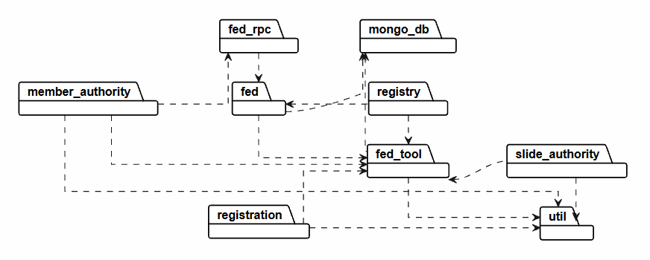
Package descriptions
No | Package | Description
01 | member_authority | Functional Role: Handles user identity classification, authorization controls (Admin, Staff, Customer, Owner), and access token validations.  Data Integration: Executes read/write operations on the MongoDB Users Collection. It validates credentials, session states, and security claims by accessing field states such as twoFactorEnabled, role, and the embedded sub-document array UserLogins.
02 | registration | Functional Role: Coordinates the onboarding workflow for guests registering as Renters or vehicle Owners, alongside managing account activation cycles.  Data Integration: Checks for field uniqueness constraints regarding user email and phone numbers before executing document insertions into the MongoDB Users Collection. It also transiently verifies account status changes via One-Time Password (OTP) records.
03 | fed_rpc | Functional Role: Serves as the Remote Procedure Call (RPC) gateway interface for incoming remote request handling.  Data Integration: Encapsulates API requests, serializes execution payloads, and handles parameters regarding incoming booking timelines from client applications before delegating the control flow downwards to lower-level services.
04 | fed | Functional Role: Functions as the primary core business logic engine and central front-end dispatching orchestrator for the entire application.  Data Integration: Moderates the core rental transactional workflows mapped to the MongoDB Booking Collection. It validates voucher structures extracted from the MongoDB Discount Collection and ensures collision-free vehicle booking schedules.
05 | mongo_db | Functional Role: Operates as the foundational data management persistence layer for the underlying NoSQL cluster.  Data Integration: Explicitly manages database server routing clients, maintains BSON object-mapping formatting configurations, and coordinates query optimizations across all 18 primary database collections (including Vehicle, Booking, Contract, Payment).
06 | fed_tool | Functional Role: Delivers low-level operational algorithmic libraries and computation-heavy utility scripts.  Data Integration: Computes cryptographic routines for password protection, translates physical image array manipulations, and calculates electric vehicle metric thresholds such as state-of-charge tracking arrays located inside the MongoDB BatteryLogs.
07 | util | Functional Role: Encapsulates system-wide software configurations, structural global constants, and standard payload adapters.  Data Integration: Hosts the default Jackson ObjectMapper profile to effortlessly translate Java objects to native NoSQL BSON models, sets standard timezone variables, and defines strict API system-level Error Codes.
08 | registry | Functional Role: Manages vehicle hub physical allocations, geographical zones, and station identification procedures.  Data Integration: Leverages structural GeoJSON geospatial modeling combined with database-level 2dsphere indexes on the MongoDB Locations Collection to pinpoint coordinate arrays for vehicle pick-up and drop-off hubs.
09 | slide_authority | Functional Role: Separates isolated supervisory review workflows and credentials verification auditing pipelines.  Data Integration: Oversees the verification pipelines for eKYC identification objects (National ID, Driving Licenses) hosted within the MongoDB UserDocument Collection and logs physical vehicle handover damage records inside MongoDB VehicleConditionLogs.

II. Requirement Specifications

1. Authentication Feature

1.1 UC-01: Login System (Đăng nhập hệ thống)

a. Functionalities
Functional Description Template
UC ID and Name: | UC-01: Login
Created By: | Bao Uyen | Date Created: | 27/5/2026
Primary Actor: | Customer | Secondary Actors: | Staff, Admin
Trigger: | The user clicks on the "Login" button on the navigation bar or is automatically prompted to log in when trying to access a protected feature (e.g., booking a bike or adding a vehicle to favorites).
Description: | Allows registered users to authenticate into the application using their standard system credentials (Email and Password) or via Google Single Sign-On (SSO) to access role-specific system capabilities.
Preconditions: | - The user must have a registered account existing in the system database.  2. The user's account must not be currently locked or suspended.
Postconditions: | - A secure active session token (JWT) is generated for the authenticated user.  - The user is successfully redirected to their designated system role dashboard.  3. The failed login attempt counter for the account is reset to zero.
Normal Flow: | - The system displays the Authentication form containing input fields for Email and Password, a "Login" action button, and a "Login via Google" button.  - The user inputs their registered Email and Password into the corresponding fields and clicks the "Login" button.  - The system captures the inputs, hashes the plaintext password string, and queries the database to match credentials.  - The system validates that the credentials match and that the account status is active.  - The system generates a secure authentication session token (JWT).  - The system identifies the user's role and redirects them to their designated entry dashboard (Customer Catalog, Staff Operational Board, or Admin Dashboard).
Alternative Flows: | 2a. Login via Google SSO:  - At step 2, the user clicks the "Login via Google" button.  - The system initiates an authentication request and routes the user to the secure Google OAuth 2.0 API gateway page.  - The user selects and confirms their Google account identity.  - Google returns a secure validation token to the system.  - The system intercepts the token and validates the email address:  - If the Google email does not exist in the database, the system automatically registers a new account with the role of Customer and lands them on the Catalog.  - If the email already exists, the system directly initializes the user session and routes them to their landing dashboard.
Exceptions: | 3a. Invalid Authentication Credentials:  - The system detects that the email address does not exist or the password hash does not match the database record.  - The system increments the failed login attempt counter for that specific account.  - The system rejects the entry, clears the password field, and displays an error message: "Invalid Email or Password. Please try again."
Priority: | High (Medium, Low), Must Have (Should Have, Could Have),..
Frequency of Use: | Extremely High (Executed every time an actor accesses a protected session).
Business Rules: | BR-AUT-01 - BR-AUT-02
Other Information: | Session tokens are configured to expire automatically after 24 hours of inactivity for security compliance.
Assumptions: | The user has a stable internet connection capable of communicating with the system servers and the external Google OAuth server.

b. Business Rules
Provide the business rules those are applied only to the use case
ID | Business Rule | Business Rule Description
BR-AUT-01 | Password Encryption Security | All plaintext user account passwords must be salted and cryptographically hashed using the secure BCrypt algorithm configuration before hitting database persistence layers.
BR-AUT-02 | Account Brute-Force Lockout | If an account hits 5 consecutive failed authentication login credential matches, the system security firewall triggers an automated temporary lock on the target account profile row for 15 minutes.

2. Booking Feature

2.1 UC-BKG-01: Create Booking

a. Functionalities
Functional Description Template
UC ID and Name: | UC-BKG-01: Create Booking
Created By: | Bao Uyen | Date Created: | 27/5/2026
Primary Actor: | Customer | Secondary Actors: | Admin
Trigger: | The customer clicks the "Book Now" action button on the specific Motorbike Details View screen.
Description: | Enables authenticated customers to specify a rental schedule, check real-time fleet availability, calculate exact rental costs, and submit a formal reservation request for a selected motorbike.
Preconditions: | - The customer must be logged into a valid system account.  - The selected motorbike asset must be flagged with an active status code of Available in the database.
Postconditions: | - A new booking transaction record is provisioned in the database with a status of Pending.  - The selected motorbike is temporarily reserved, blocking other users from reserving it during the requested timeframe.  - An itemized invoice breakdown is generated and stored.
Normal Flow: | - The system displays the Booking Checkout form presenting the selected vehicle information and input elements for the rental schedule.  - The customer selects the Rental Start Date/Time and Rental End Date/Time, uploads their Citizen ID image file, and selects a payment method.  - The system triggers the background Check Availability and Rental Conflict Validation routines to ensure the vehicle has no overlapping bookings within that timeframe.  - The system executes the Rental Price Calculation engine to dynamically compute the total contract price based on duration, unit daily rates, taxes, and active promotion discounts.  - The system displays the itemized financial summary to the customer for final review.  - The customer confirms all details and clicks the "Confirm Booking" button.  - The system logs the new transaction record into the database with a state tag of Pending and temporarily reserves the vehicle asset row.  - The system executes the Booking Confirmation mechanism, flashing an in-app system notification and sending a confirmation receipt email to the customer.
Alternative Flows: | 6a. Customer selects Online Payment Gateway:  - At step 6, the customer selects "Online Payment" and clicks the payment button.  - The system packages the transaction meta-data and redirects the customer to the third-party secure payment gateway interface (e.g., VNPAY).  - The customer authorizes and processes the digital transaction successfully.  - The payment gateway returns a secure success callback payload to the system API.  - The system instantly modifies the booking state from Pending to Confirmed, records the payment history log, and secures the fleet reservation.
Exceptions: | 3a. Target Vehicle Rental Schedule Conflict:  - The database query engine detects that the chosen vehicle ID is already bound to an active or confirmed contract that overlaps with the selected timeframe.  - The system disables the final confirmation controls and highlights an explicit error toast message: "The selected motorbike is unavailable during this time frame. Please select another schedule or vehicle."
Priority: | High (Medium, Low), Must Have (Should Have, Could Have),..
Frequency of Use: | Very High (Core transactional process executed multiple times per hour).
Business Rules: | BR-AUT-01 - BR-AUT-02
Other Information: | Temporary vehicle holds for Pending orders using the cash payment option automatically expire and release the bike if not approved by staff within 2 hours.
Assumptions: | Fleet availability charts and currency prices are fully up to date at the moment the client loads the form interface.

b. Business Rules
Provide the business rules those are applied only to the use case
ID | Business Rule | Business Rule Description
BR-AUT-01 | Minimum Rental Increment | The minimum billing rental increment for any contract booking is exactly 1 day (24 hours). Early returns occurring prior to the 24-hour mark are billed at the full 1-day rate.
BR-AUT-02 | Rental Price Compilation | Gross reservation total fees are derived dynamically via the formula: Total = [Total Contract Days * Unit Motorbike Price Per Day] - [Active Promotion Coupon Discount Value] + [System Processing Taxes].

3. Verification Feature

3.1 UC-VRF-01: Upload & Verify Citizen ID

a. Functionalities
Functional Description Template
UC ID and Name: | UC-VRF-01: Upload & Verify Citizen ID
Created By: | Bao Uyen | Date Created: | 27/5/2026
Primary Actor: | Customer | Secondary Actors: | Admin
Trigger: | The customer navigates to their Account Profile Settings page or hits the verification gate block during the checkout process and clicks the "Upload Identity Documents" button.
Description: | Provides a secure workflow for customers to upload images of their national identity documentation (Citizen ID / CCCD) to comply with vehicle rental regulations, allowing system admins to inspect and verify their legal identities.
Preconditions: | - The customer must have a valid account session established.  - The customer's identity status must be currently marked as Unverified or Rejected.
Postconditions: | - The customer's profile file paths are updated with valid URLs pointing to the secure media server storage containers.  - The customer's global account status variable transitions to Pending Verification or Verified based on Admin review.
Normal Flow: | - The system opens the Identity Upload component modal, displaying file constraints (.jpg, .png formats; maximum file size of 5MB per image).  - The customer uploads clear images of both the front and back of their Citizen ID card and clicks the "Submit for Verification" button.  - The system uploads the images to a secure file server container, links the encrypted asset URLs to the customer's account profile row, and flags the account verification status as Pending Verification.  - The Administrator logs into the system backend portal and opens the User Verification Management panel.  - The system queries and lists all account records marked as Pending Verification along with their uploaded ID image viewers.  - The Administrator evaluates the legibility, authenticity, and text match of the ID document images and clicks the "Approve/Verify" button.  - The system updates the customer's account profile record status to Verified, removing booking blocks and allowing staff to execute actual physical vehicle handovers.
Alternative Flows: | 6a. Uploaded Documentation Images Irregular or Legally Invalid:  - The Admin determines that the uploaded image files are blurry, corrupted, altered, or contain conflicting data, and clicks the "Reject Submission" button.  - The system prompts the Admin to input a specific reason for rejection from a dropdown selection or custom text field.  - The system resets the user's validation status to Rejected and stores the feedback reason.  - The system automatically sends an asynchronous live System Notification` and email alert to the Customer screen requesting a clean document re-upload.
Exceptions: | 3a. Target Vehicle Rental Schedule Conflict:  - The database query engine detects that the chosen vehicle ID is already bound to an active or confirmed contract that overlaps with the selected timeframe.  - The system disables the final confirmation controls and highlights an explicit error toast message: "The selected motorbike is unavailable during this time frame. Please select another schedule or vehicle."
Priority: | High (Medium, Low), Must Have (Should Have, Could Have),..
Frequency of Use: | Medium (Executed once per customer account creation or document update).
Business Rules: | BR-VRF-01
Other Information: | Uploaded images are strictly encrypted at rest using AES-256 formatting to ensure maximum data privacy compliance.
Assumptions: | The image uploading module correctly processes basic binary file headers to block malicious script execution masquerading as image files.

b. Business Rules
Provide the business rules those are applied only to the use case
ID | Business Rule | Business Rule Description
BR-VRF-01 | Verification Precondition for Pickup | Store Staff are barred from executing actual physical vehicle pickup actions (Confirm Bike Pickup) if the customer profile identity state variable does not equal Verified.

III. Design Specifications

1. <<Feature Name>>

1.1 <<SubFeature Name>>

a. <<Screen/Function Name>>
[Provide brief description of the screen/function + related UC here and other details as in the sub-sections]

UI Design
[This is to describe the UI layout (Mockup prototype) & descriptions for screen fields/components]
<<Mockup prototype>>
Field Name | Field Type | Description
Field Group Name
<<Field-Name>> | <<Field type>> | <<Field description & data initializing design>>

Database Access
[Provide the design description for the screen/function to access the database here: what table the screen/function would access, which transactions does it make (C-Create, R-Read, U-Update, or D-Delete), and how/purpose of the access (by providing Description and SQL commands)]
Table | CRUD | Description
<<Table Name>> | <<transaction(s)>> | <<Table access description: purpose, how,…>>
..

SQL Commands
[Provide the detailed SQL (select, insert, update...) which are used in implementing the screen/function]

1.2 System Access

a. User Login
This screen allows user to be authenticated to the system screens/functionalities.
Related use cases:
- UC02_Login System

UI Design
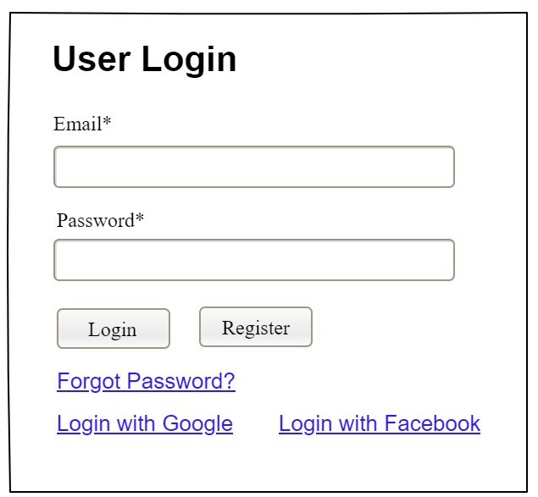

Field Name | Field Type | Description
Email* | Text Box | This is for user to input valid email address for logging in
Password* | Password Box | This is for user to input password for logging in
Login | Button | User clicks to authenticate him/herself into the system with provided email & password
Register | Button | User clicks to redirect to the User Register page for registering new user account to access the system
Forgot Password? | Hyperlink | User clicks to redirect to the Password Reset page for resetting his/her forgot password
Login with Google | Hyperlink | Allow user to login with his/her Google account
Login with Facebook | Hyperlink | Allow user to login with his/her Facebook account

Database Access
Table | CRUD | Description
User | R | Verify UserName & Password information
Setting, User | R | Specify the authorizations of the logged-in user

SQL Commands:
1/ Verify UserName & Password information
SELECT user_id, full_name, email, image_url, status
FROM user WHERE user_name = ? AND password = ?

2/ Specify the authorizations of the logged-in user
SELECT mapped_values FROM setting WHERE setting_id = ?
SELECT setting_name, mapped_values FROM setting WHERE setting_id IN (?)

b. Setting List

UI Design
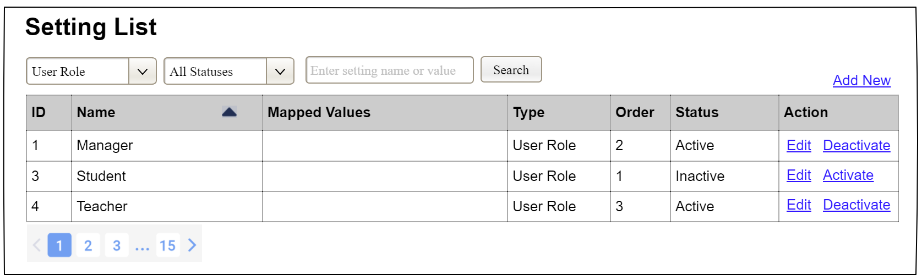

Field Name | Field Type | Description
Search Fields
Setting Type | Combo Box  Single-Choice | Filled with the list of current active setting types  Allow to filter the list by setting type;  Default value is “All Types”
Setting Status | Combo Box  Single-Choice | Values: All Statuses (default), Active, and Inactive  Allow to filter the list by status  Default value: “All Statuses”
Search Phase | Text Box  String (30) | Allow to search using the name or map values  Default value: blank
Search | Button | Click to refresh the list with the defined filter(s) and search phrase.
Add New | Hyperlink | Click to open the Setting Details page for adding new setting (master data)
Data Table
ID | Integer | Auto-increased identifier of the setting
Name | Text | Name of the setting
Mapped Values | Text | Supplementary information for the setting
Type | Text | Type of the setting
Order | Integer | Display order of the setting: the order of the setting type, displayed among the list of settings with the same type
Data Actions
Edit | icon | Click to open the Setting Details page for updating the relevant setting (master data)
Activate | icon | Shown when the data status is inactive. This is to activate the relevant setting (master data)
Deactivate | Ion | Shown when the data status is active. This is to deactivate the relevant setting (master data)

Database Access
Table | CRUD | Description
Setting | RU | Query the list of current settings from the database  Update status of a specific setting

SQL Commands:
1/ Query the list of current settings from the database
SELECT setting_id, setting_name, mapped_values, type_id, display_order, status
FROM setting WHERE (setting_type = ?) AND (status = ?) AND (setting_name LIKE ?)

2/ Update status of a specific setting
UPDATE setting SET status = ? WHERE setting_id = ?

c. Setting Details

UI Design
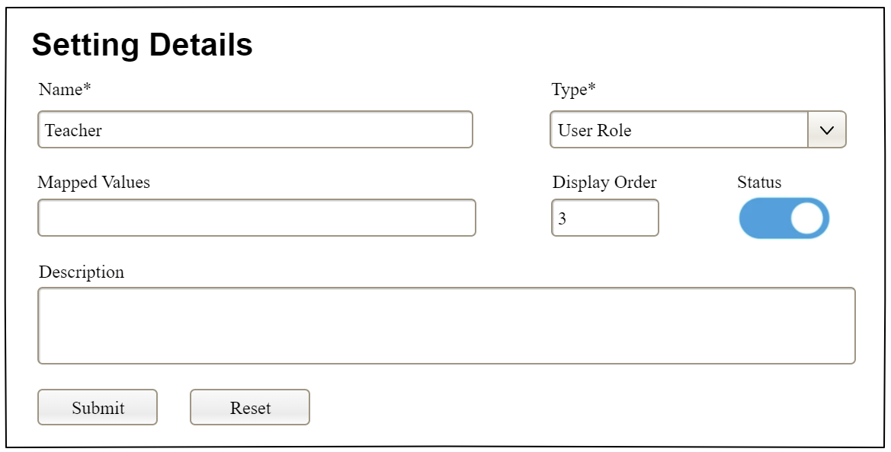

Field Name | Field Type | Description
Name* | Text Box  String (20) | Name of the setting
Type* | Combo Box  (Single Choice) | Type of the setting, filled with the list of setting types  Default value: the first type in the list
Mapped Values | Text Box  String (50) | Supplementary information for the setting (if any)
Order | Text Box  Integer (>=0) | Display order of the setting: the order of the setting type, displayed among the list of settings with the same type
Status | On/Off button | Status of the setting: Active or Inactive  Default value: Active
Description | Text Area  String (200) | Description of the setting
Submit | Button | Click to store new or updated setting details
Reset | Button | Click to reset the changes use has made on the screen fields back to the initial values when the screen is loaded

Database Access
…

IV. Appendix

1. Assumptions & Dependencies
[Record any assumptions that were made when conceiving the project and writing this vision and scope document. Note any major dependencies the project must rely upon for success, such as specific technologies, third-party vendors, development partners, or other business relationships.]
<<Sample:
AS-1: Systems with appropriate user interfaces will be available for cafeteria employees to process the expected volume of meals ordered.
AS-2: Cafeteria staff and vehicles will be available to deliver all meals for specified delivery time slots within 15 minutes of the requested delivery time.
DE-1: If a restaurant has its own on-line ordering system, the Cafeteria Ordering System must be able to communicate with it bi-directionally.
>>

2. Limitations & Exclusions
[Identify any product features or characteristics that a stakeholder might anticipate, but which are not planned to be included in the new product]

3. Business Rules
[Provide common business rules that you must follow. The information can be provided in the table format as the sample below]
<<Sample
ID | Category | Rule Definition
BR-01 | Constraints | Delivery time windows are 15 minutes, beginning on each quarter hour.
BR-02 | Constraints | Deliveries must be completed between 10:00 A.M. and 2:00 P.M. local time, inclusive.
BR-03 | Facts | All meals in a single order must be delivered to the same location.
BR-04 | Facts | All meals in a single order must be paid for by using the same payment method.
BR-11 | Constraints | If an order is to be delivered, the patron must pay by payroll deduction.
BR-12 | Computations | Order price is calculated as the sum of each food item price times the quantity of that food item ordered, plus applicable sales tax, plus a delivery charge if a meal is delivered outside the free delivery zone.
>>

4. ..

